**How to delete cookies and disable the cookies in browser**

1. **Find the settings for cookie in chrome**



1. **Check all the cookies..**

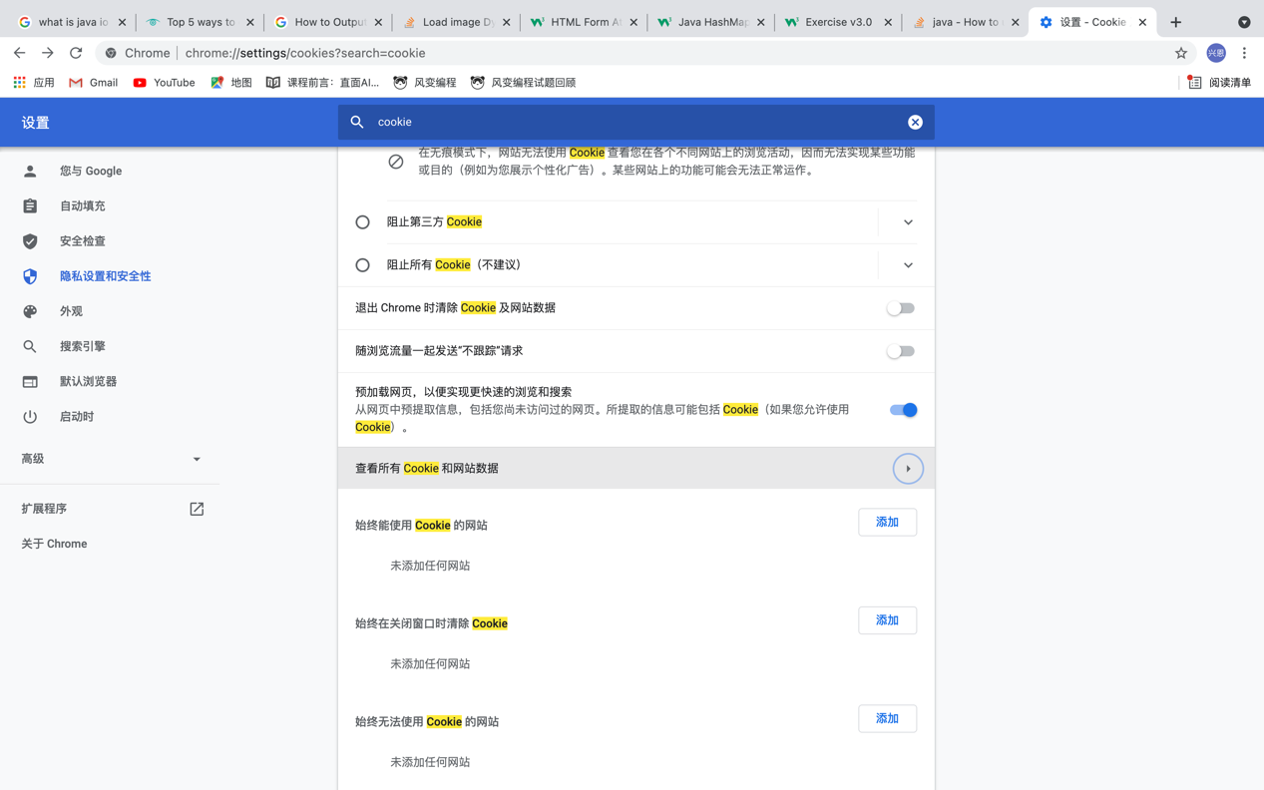

1. **Click delete all to delete them.**

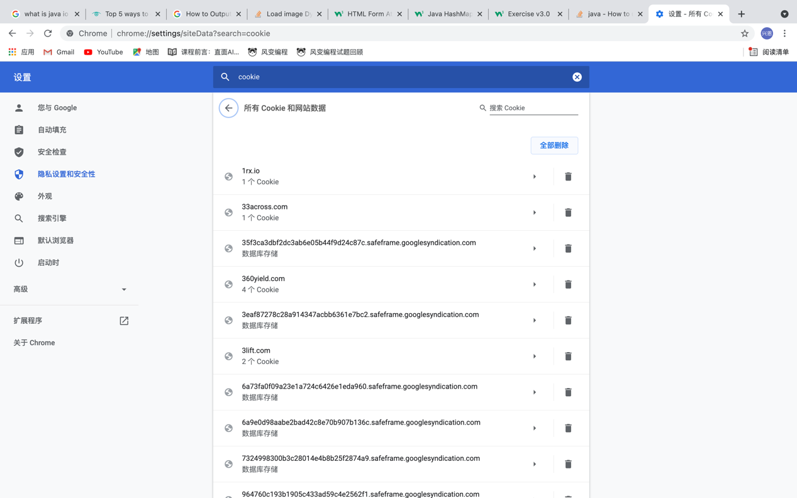

1. **Click the check box to disable the cookies**

